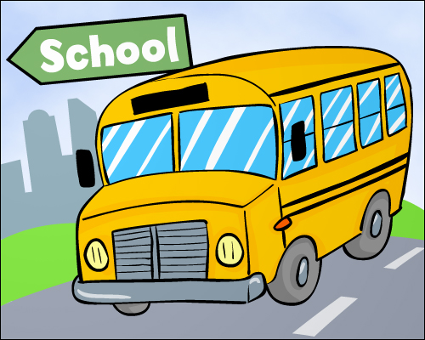

**Third Grade News**

**Mrs. Eiken’s Class**

**December 3, 2021**

|  |  |  |  |  |
| --- | --- | --- | --- | --- |
| **monday** | tuesday | wednesday | thursday | friday |
| **6** | **7** | **8** | **9**  Holiday Concert 6:30 pm(4/5 grade) | **10** |
| **13**  **PTO Zoom 6:30** | **14** | **15** | **16**  **Holiday Party**  **Texas Roadhouse night** | **17**  **3 hour early**  **Dismissal for Winter Break** |
| **3**  **Classes Resume** | **4** | **5** | **6** | **7**  **End of 2nd Quarter**  **Virtual Awards Assembly** |

**December/January**

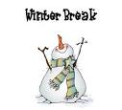

**Friday, December 17th, school will dismiss at 11:45 a.m. for all students. If your child will have different after-school arrangements on this early release day, please notify me or the office. (BOYS AND GIRLS CLUB WILL BE CLOSED ON THE 17th). We will be back to school on Monday, January 3rd, 2022. I hope your family has a safe and happy Winter Break!**

**Thank you to those who have sent in wrapping supplies for our holiday store. It’s not too late to donate tape, giftwrap, bags or other wrapping supplies.**

**At West Elementary School, we provide students with “I can” statements to set a purpose for our learning each day. Our learning goals for this week are…**

**Literacy:**

*I can use context clues to determine the meaning of unknown words and words with more than one meaning.

*I can draw conclusions and support with text evidence.

*I can describe the relationship between events, ideas, concepts, or steps.

*I can describe the relationship between a cause and effect.

**Math:**

*I can divide by 2, 5, 10, 3, 6, and 4.

**Writer’s Workshop**:

*I can find relevant sources to answer my question.

*I can reference sources or authors within my piece.

*I can locate information related to my topic and take notes.

*I can include a main idea and supports in my writing.

*I can follow the writing process to write a draft.

**Social Studies/Science-** We continue our science unit on life cycles.

**Specials**

**Monday: Music**

**Tuesday: PE**

**Wednesday: Art**

**Thursday: Music**

**Friday: PE**

**We will have our winter party on Thursday, December 16th. We will be watching The Grinch and have Grinch floats. We will also have a special snack on Friday the 17th. If you are interested in helping send in supplies, please let me know. Thanks!**